Oath for Software Engineers

"As a responsible software engineer, I pledge to uphold the highest ethical standards in my work. I will:
- Act with Integrity – Ensure honesty, transparency, and fairness in all aspects of software development.
- Prioritize User Safety and Privacy – Protect user data, privacy, and security in software systems.
- Adhere to Professional Standards – Follow industry best practices, legal regulations, and ethical guidelines such as the ACM Code of Ethics and the IEEE Software Engineering Code of Ethics.
- Ensure Quality and Reliability – Develop software that is safe, reliable, and efficient, avoiding negligence or shortcuts that may compromise system integrity.
- Respect Intellectual Property and Avoid Plagiarism – Acknowledge and credit the work of others, ensuring originality in software solutions.
- Practice Social Responsibility – Recognize the societal impact of software and contribute positively to technology development.
- Report Ethical Violations – Speak out against unethical practices and support a culture of accountability and professionalism."

Signature:
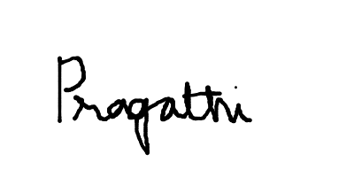

Name / USN:Pragathi BR /1NT24IS153
Date:02/02/2026
Place:NMIT

